Module 8 – SAS Code and Screenshots

Jim Tipton
Colorado State University Global
MIS581 – Capstone: Business Intelligence and Data Analytics
Dr. Orenthio Goodwin
May 15, 2022

* Load the 'Kickstarter and Kicktraq' dataset;

PROC IMPORT DATAFILE= '/home/u38439745/sasuser.v94/Kickstarter and Kicktraq.xlsx'
DBMS=XLSX
OUT=WORK.KS_KT;
GETNAMES=YES;
RUN;

* Load the 'Kickstarter with Attributes' dataset;

PROC IMPORT DATAFILE= '/home/u38439745/sasuser.v94/Kickstarter Projects with Attributes.xlsx'
DBMS=XLSX
OUT=WORK.KS_ATTRIBUTES;
GETNAMES=YES;
RUN;

* Validate data loads;

PROC PRINT DATA=WORK.KS_ATTRIBUTES (obs=50);
RUN;

PROC PRINT DATA=WORK.KS_KT (obs=50);
RUN;

* Concatenate the two datasets together for easier analysis;

DATA KS_Combined;
set WORK.KS_ATTRIBUTES WORK.KS_KT;
RUN;

* Validate Concatenate;

PROC PRINT DATA=KS_Combined (obs=50);
RUN;

* Recode Values;

proc format;
value ResultFrmt
0 = "Fail"
1 = "Success"
other = " ";
value MonthFrmt
1 = "January"
2 = "February"
3 = "March"
4 = "April"
5 = "May"
6 = "June"
7 = "July"
8 = "August"
9 = "September"
10= "October"
11= "November"
12= "December"
other = " ";
value YesNoFrmt
0 = "No"
1 = "Yes"
other = " ";
RUN;

* Exploration;

* Overall Means of select variables;

Proc Means data=KS_Combined nolabels MAXDEC=2;
var Goal_USD Pledge_USD Backers_Count Duration Founder_Experience Result;
Run;

* Means by Category;

proc sort data=KS_Combined out=KS_Category;
by Category;
run;

Proc Means data=KS_Category nolabels MAXDEC=2;
var Goal_USD Pledge_USD Backers_Count Duration Founder_Experience Result;
By Category;
Run;

* Means by Month;

proc sort data=KS_Combined out=KS_Month;
by StartMonth;
run;

Proc Means data=KS_Month nolabels MAXDEC=2;
var Pledge_USD Backers_Count result;
by startmonth;
format startmonth MonthFrmt.;
Run;

* Hypotheses

* H1 - Does being a staff pick increase success chance;

PROC REG DATA=KS_Combined plots(Maxpoints=17000);
Model Result=StaffPick;
Format Result Resultfrmt.;
Format StaffPick YesNoFrmt.;
RUN;

PROC CORR DATA=KS_Combined;
VAR StaffPick;
WITH Result;
RUN;

* H1 - Does being featured increase success chance;

PROC REG DATA=KS_Combined plots(Maxpoints=17000);
Model Result=Featured_Project;
Format Result Resultfrmt.;
Format Featured_Project YesNoFrmt.;
RUN;

PROC CORR DATA=KS_Combined;
VAR Featured_Project;
WITH Result;
RUN;

* H2 - Does more founder experience increase success chance;

PROC REG DATA=KS_Combined plots(Maxpoints=17000);
Model Result=Founder_Experience;
Format Result Resultfrmt.;
Run;

PROC CORR DATA=KS_Combined;
VAR Founder_Experience;
WITH Result;
RUN;

Exploration Screenshots

Means of select fields

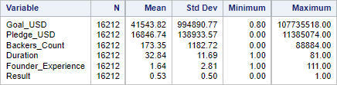

Means of select fields by ‘category’

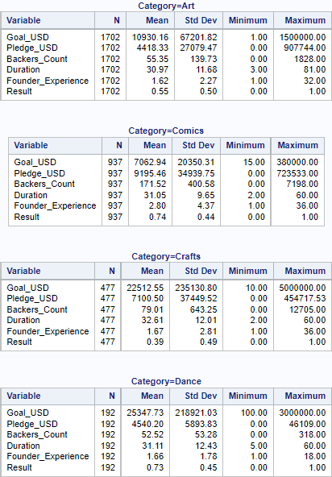
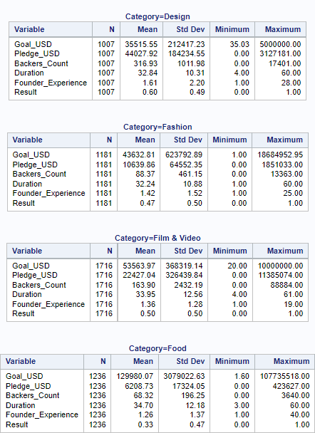
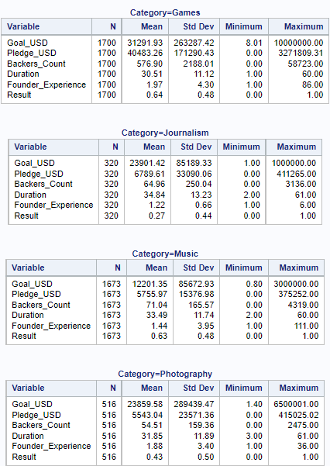
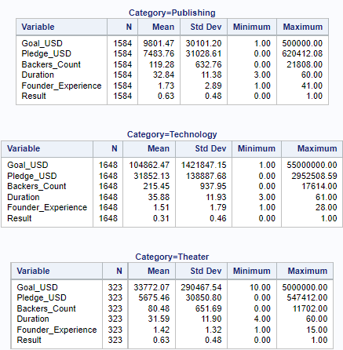

Means of select variables by ‘StartMonth’

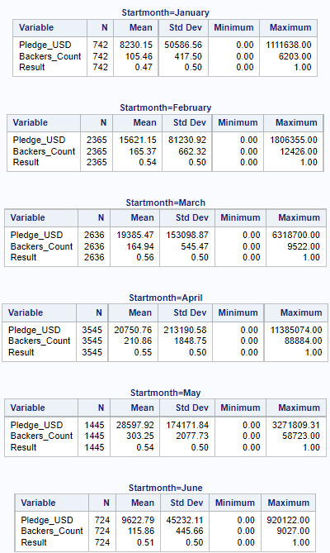
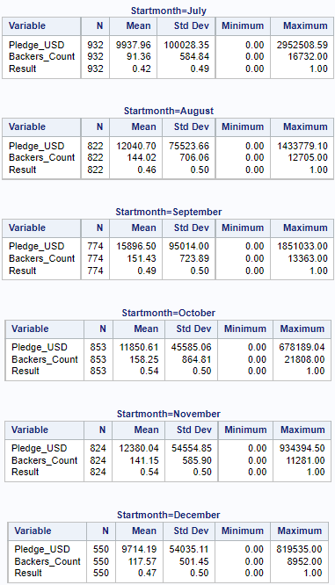

Hypothesis Testing

H1 – Does being a ‘staff pick’ increase chances of success?

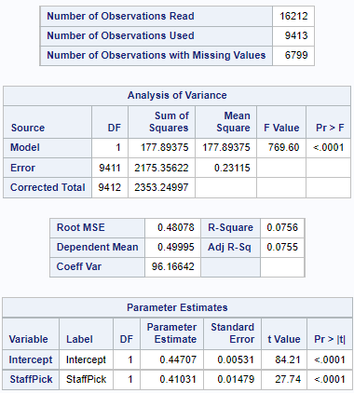

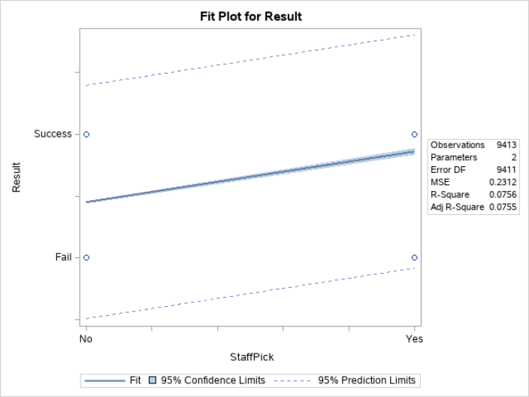
H1 – Does being ‘featured’ increase chances of success?

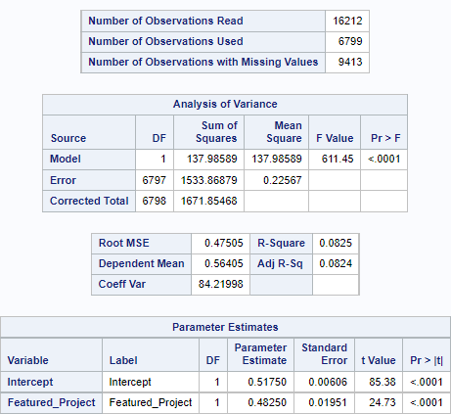

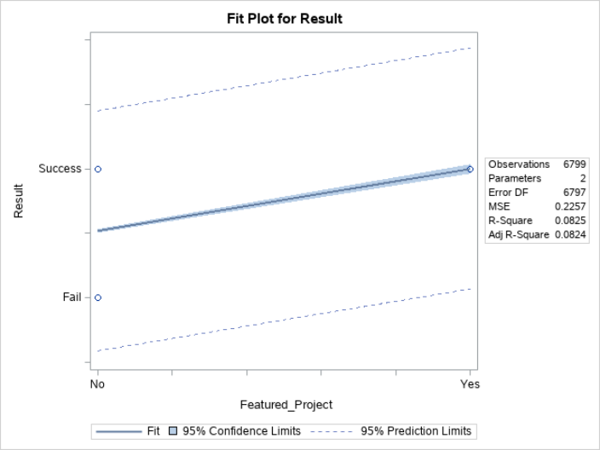
H2 – Does a creator having more past projects increase chances of success?

